**Report/Ethical Reflection**

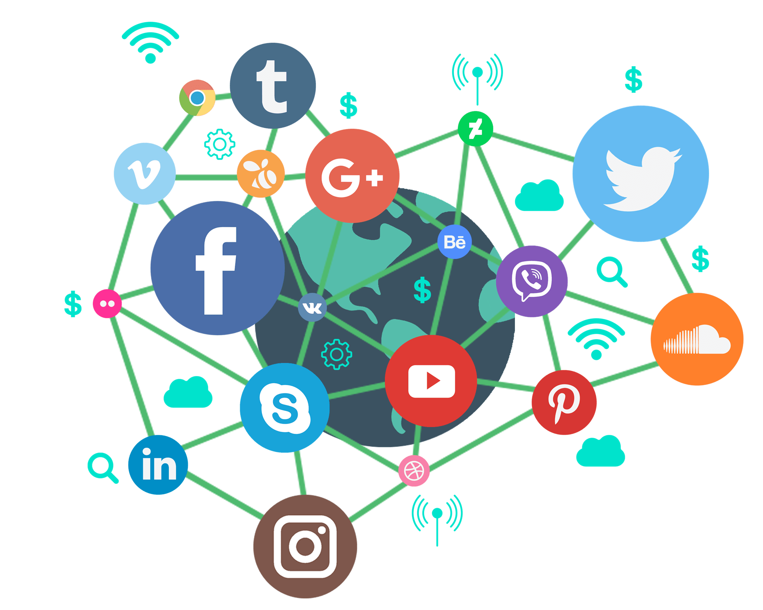A social media, according to Merriam-Webster (2021), is an internet platform hosted by a private company that allows users/customers to join in order to communicate with friends, express ideas, share multimedia, and join online communities. Because of their involvement in both personal and private life, social media as a technology features many choices, opportunities, and risks. The choices afforded by social media includes data, targeted advertising, and free communication. Social media companies can provide many different opportunities for businesses, individuals, and education providers. Platforms also have a lot of power, which brings the risk of privacy, production loss and even vigilantism.

The choices a social media company/platform can have requires a careful balancing act of need and want. One choice a social media company has is data. Data is to social media like butter is to bread. Without data a social media cannot bloom full of users and communities, but how much data should a social media company have? It’s easy to say they should only keep important user data like name, age, and email address but there is other data such a user posts, multimedia, friends, groups, posts they liked, links they’ve clicked, number of followers, previous internet activity, etc. Another choice data give is how to store and display this data. On the computers of users in fragmented chunks, privately owned servers, amazon web services servers, or multiple servers around the world. When displaying data should images and videos be shown one by one, in collages, with text, should edges be rounded, should they expand when the mouse hovers over them? With data, there are many small choices that ultimately build up to a platform’s entire design methodology and mission statement. When working with data it is important for a business to secure that data and to also inform users on what data they are collecting. The New Zealand privacy commissioner says “Under the privacy act agencies organizations and businesses have to respect your personal information, which is any information that can identify you as an individual. This can include but is not limited to your name, your address, a picture of your face, a record of your opinion and views, employment information, health records, and financial information.” It is also a requirement of agencies that they keep personal information for no longer than is necessary and is only stored if it is necessary. These legal expectations for businesses ensure the protection of individuals personal information and private data.

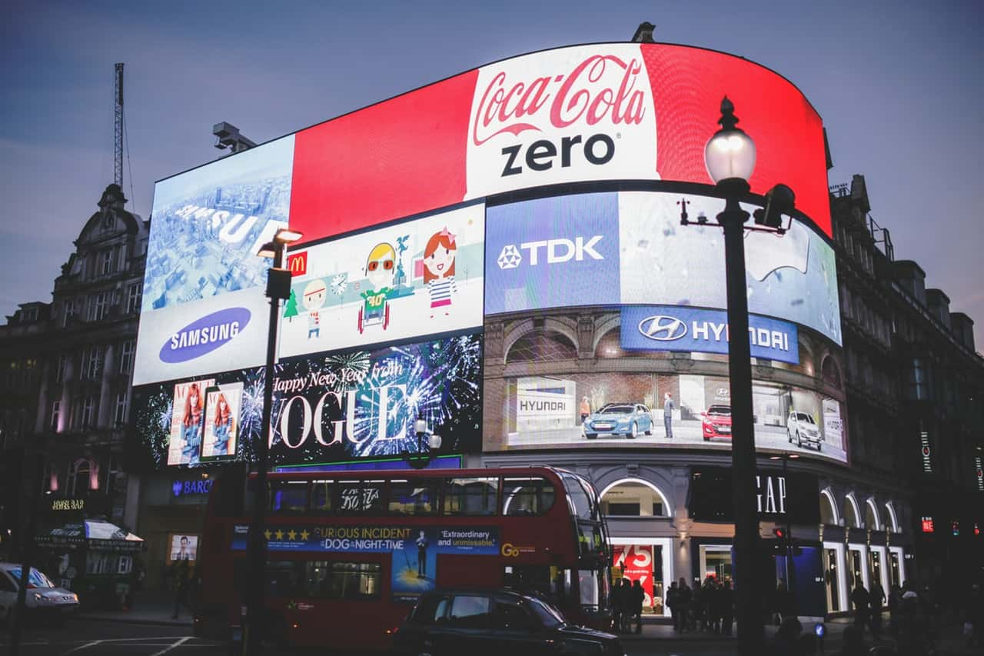Another choice afforded by social media is targeted advertising. Targeted advertising relies on tracking user activity and then displaying advertisements for products or services that relate to said activity. While targeted advertising is not necessarily exclusive to social media, it is widely accepted that because social media has far more access to personal and private information it can use the information it collects to advertise to specific audiences and consumers far more efficiently than any other platform. This power to advertise directly to consumers based on what is known about them opens up a gradient of choices, from the darkest choice being complete collection of data and constant advertising to the lightest choice which would be no tracking and randomly distributed ads. Most companies sit in the Gray area where they will always try to preserve privacy while also maintaining a minimum level of tracking in order to provide more relevant advertisements. Whether or not a company is tracking too much or too little is a nuanced question and can only be answered from person to person on a case by case basis. I attempted to find data on how much social media companies track users in order to plot them on a black to white gradient, but unfortunately was unable to find such data, but, I did come across a Forbes article that teased my futile efforts titled “Social media companies collect so much data even they can't remember all the ways they surveil us” by Kalev Leetaru (2019). The choice to track user information in order to advertise directly to consumers 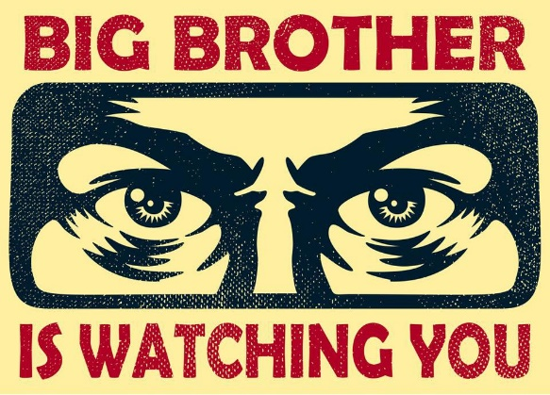can be a double-edged sword. To consumers it can be detrimental to mental health knowing that all your data is being used to target you and your wallet, but, it could also be seen as a positive by both consumers and businesses as more relevant advertisements are being shown to the people who need to see them the most. Nevertheless, whether tracking user data to provide targeted advertisements is good or bad is irrelevant. The power is in the hands of social media companies and developers to use the powers they have in a way that they see most responsible.

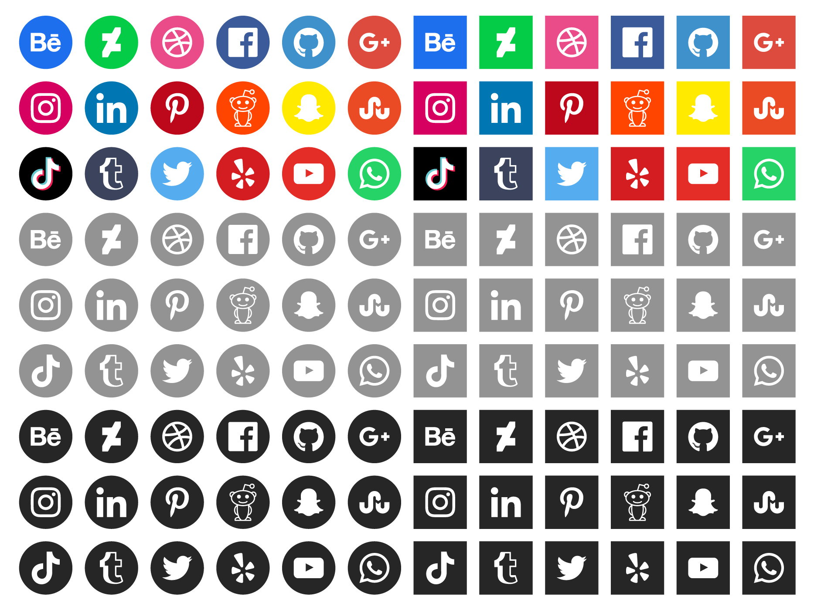A critical and obvious choice brought about by social media is often overlooked, that of course being free communication. Because the Internet is an open interconnect of systems that isn't owned by anyone, the ability to produce and create your own social media has never been easier. Because of this, the social media industry is filled to the brim with different choices. This seemingly limitless amount of choice gives the users the freedom to select which platform they prefer. Free choice for the consumers method of communication and the competition between social media companies to produce the best methods of communication lead to the creation of highly polished websites and applications that better serve the users. This creation of highly polished websites and applications leads to the furthering of technology as a whole that pushes more competition more choice for users and ultimately creates a feedback loop that continuously attempts to improve technology further and further. This is a simple reason as to why technology has moved so quickly over the past decade. Ultimately, social media platforms are created for the users that use them. Without users and customers, social media platforms cannot exist. Because of this fact, ultimately, consumers have the most choice when it comes to social media, but it is up to them as to whether they use their free will or not.



When it comes to opportunities of social media, in business, the nature of social media makes companies more directly target customers with marketing campaigns. Specifically, social media can be a cheap and effective method to start a marketing campaign, with a profitable impact possible from minimal investment. The social media strategy should contain an intelligent mix of engaging content and a friendly and responsive ‘persona’ that can grow a focused community interested in companies’ products, service, and brand that can recommend their business to others. As an example of this, Khan state that “from a marketing point of view, SNSs and social media offer many advantages regarding usage, access and cost. They are easily accessed by an ever-growing number of people through different platforms on a 24/7 basis and are demanding less financial resources are providing magnified results through their viral nature. Along with the interactive communication they offer, it makes SNSs one of the richest mediums available for marketers”. As a result, it can be a helpful, effective and efficient way to enhance the quality of the marketing system in the enterprise.

Moreover, another part of social media opportunities is the importance of SNSs for young users becoming increasingly common, social media usage has a crucial influence on job opportunity such as the content creator. To be precise, the creators are blossoming who are working on Youtube, Instagram and Facebook, since they have more opportunities to earn more on social media. To compared the present, there was not good to get a job through social media because computers or social media were not widely known. However, it can be seen anywhere nowadays. An example which Online Bachelor Degrees posted that “social media sites are also a medium informing job seekers about current job openings. Employers that use social media for recruitment purposes are able to target a broader market of potential candidates for their job positions.” Therefore, it became to be sound opportunity to get a job for job seekers.

Furthermore, using social media as Teams, Github, and Zoom at school allows students access to the online course everywhere. This is a huge opportunity to educational facilities. To be specific, it is undeniable that students can use social media to study from anywhere and anytime, thanks to advanced technologies. As an example, a recent pandemic called COVID-19 is forcing global experimentation with remote teaching. Online education has enabled the teacher and the student to set their own learning pace, and there is the added flexibility of setting a schedule that fits everyone’s agenda. Therefore, this plays a crucial role in the class lesson on certain occasions.

A risk with social media is the privacy which it offers, or should I say lack of, as a lot of apps watch what the user does on their phones even when the app is either closed or in the background. As most people knew that this was happening, they were happy to accept this when Apple released their new iOS 14.5 update earlier this year. However, this change has only happened on iOS devices and not Android devices. This gave the user the choice of if they want an app (such as Facebook, Instagram, Twitter, etc) to track their phones’ activity across other companies’ apps and websites. In early May 2021, data was released which showed that 96% of the people who got the update did not let the apps track their phones, such as seeing what the user searches and then uses that data and gives targeted adverts. Another point with privacy is if you are willing to share an image or video with someone, it can be shared or forwarded to someone or group without your permission. Therefore, this becomes a breach of the original sender’s privacy. Once the information has been shared to others which they did not want to have it, they loss control of that information and there is a risk of it being use in a different way than originally intended. One of the biggest risks that comes with privacy around social media is some people have very weak passwords for their accounts, for example password1234. If their account gets hacked, they can then use your name and information from those platforms to then potentially commit crimes, such as identity fraud, seeking money from friends and family by acting as you.

Productivity loss is also a risk that comes with social media as it can affect everyone whether you are a student at school/university, or at work, and social media is the main reason for this as it easily accessible from your phone, or computer and when on social media what feels like 10-15 mins may actually be 45 to an hour. This can have an impact on students as it can affect their marks and concentration, and businesses as an article from Business Today stated that 32% (or 2.35 hours) of employees’ time in the day is going towards looking at social media platforms. This ends up creating a domino effect, where productivity is going down due to the time spent on social media, creating a loss in profits for businesses. In an effect to help reduce the impact that this has on a business’s work force some have imposed a restriction on the computers and Wi-Fi, to block access to these websites and apps.

Vigilantism is probably one of if not the worst risks with social media, as vigilantism means to take the law into your own hands without legal authority. And that is what happened when someone on Reddit created a subreddit (of which initially had a small membership that grew and finally reached 3000 people) with the single aim to find the person who set off a bomb on the 15th of April 2013 during the running of the annual Boston Marathon. The bomb blast was responsible for the death of 3 people and injured hundreds, all of whom were in the wrong place at the wrong time. A couple of days after the bombing the FBI released some images of the suspect, from these images and research the subreddit believed they had found the suspect, Sunil Tripathi a 22 year old student who had been missing most of March that year. Then one of Sunil’s classmates tweeted that she also thought the image of the suspect was Sunil too. After these unofficial revelations people tried to contact Sunil’s family, by leaving angry messages on his Facebook page, and calling ABC News. On the same day the two people who actually set the bomb off at the Boston marathon (Dzhokhar and Tamerlan Tsarnaev) killed a police officer. The following day someone from the subreddit decided to tweet that the Boston Police Department had named Sunil Tripathi and Mike Mulugeta as people they were looking for, which caught the attention of the mainstream media. From this the BBC named Sunil Tripathi as the standout suspect on social media before the FBI named the real suspects to be Dzhokhar and Tamerlan Tsarnaev. Unfortunately, the impact of all the attention and mis-information took its toll and on the 23rd of April Sunil was found dead from drowning. While this is one example of vigilantism through social media it is not the only one and will most likely continue not just in United States of America but also all around the world.

In conclusion, these examples of the opportunities, risks, and choices shows that social media has a huge impact of the modern-day society as it is a part of a lot of people daily routine. By this I mean that at some point of the day they go onto their phones and use some sort of social media platform. An example of this is in January 2021 Statista says that it is estimated 4.2 billion people in the world use social media. This just shows that social media whether it be good or bad, create opportunities, have risks or choices, has a big part to play in modern day society.

**References:**

<https://www.frontlinegaming.org/wp-content/uploads/2019/11/hand-of-cards-768x576.jpg>

[https://miro.medium.com/max/1075/1*2A-w-KONim5R459GyY_E8Q.png](https://miro.medium.com/max/1075/1*2A-w-KONim5R459GyY_E8Q.png)

<https://static.vecteezy.com/system/resources/previews/000/095/039/original/free-social-media-icons-vector.png>

<https://www.forbes.com/sites/kalevleetaru/2018/10/25/social-media-companies-collect-so-much-data-even-they-cant-remember-all-the-ways-they-surveil-us/?sh=40809d0b7d0b>

<https://i.imgur.com/yJyQweT.png>

<https://arstechnica.com/gadgets/2021/05/96-of-us-users-opt-out-of-app-tracking-in-ios-14-5-analytics-find/>

<https://www.businesstoday.in/current/corporate/social-media-affecting-workplace-productivity-report/story/238716.html>

<https://en.wikipedia.org/wiki/Sunil_Tripathi>

<https://www.statista.com/statistics/273476/percentage-of-us-population-with-a-social-network-profile/>